**NORTH KENT LAWN TENNIS ASSOCIATION**

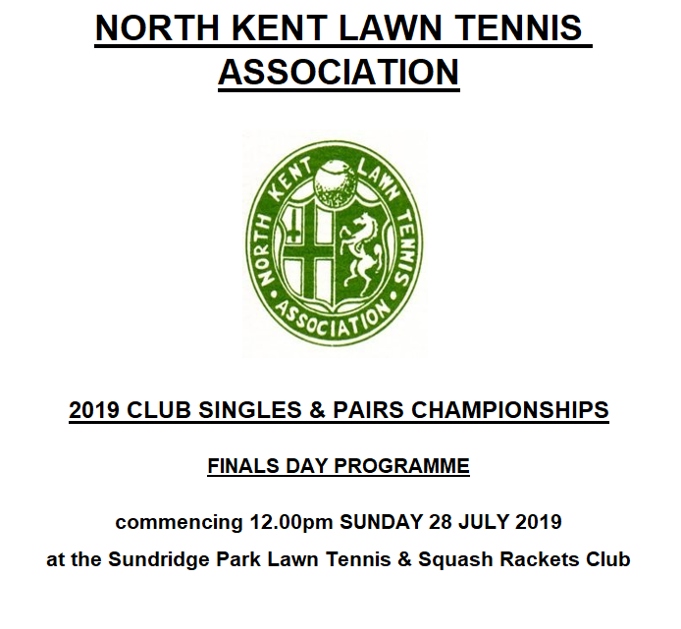

**CLUB SINGLES & PAIRS CHAMPIONSHIPS 2022**

**80th YEAR**

**FINALS DAY PROGRAMME**

***commencing 12.00pm on Sunday 31st July 2022***

***at The Sundridge Park Club***

**INTRODUCTION**

Below: North Kent Cup Finals Day 2022 – The Sundridge Park Club

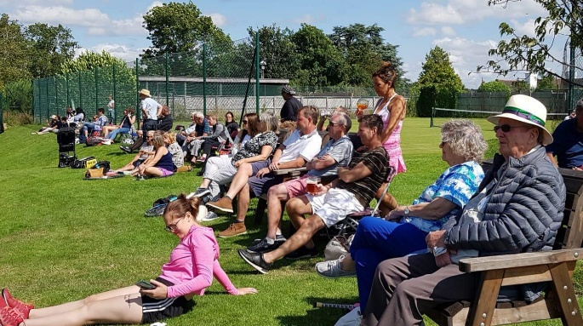 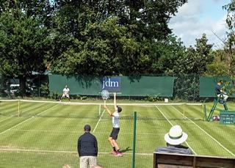

Welcome to the 80th Finals Day of the North Kent LTA Cup Competition.

This year we are again kindly being hosted by The Sundridge Park Club, recently voted LTA Kent Club of the Year 2022 following their success of being voted National runner-up in 2021. Our thanks go to their committee and members for their kind hospitality for hosting our event in such scenic surrounds since 2018. Following the disappointing yet inevitable cancellation of the 2020 event due to lockdown, the opportunity to play on grass courts once more and following last year’s success, was too good an offer to refuse. Their previous hard work in preparing the courts is much appreciated, and we hope for some good weather again this year!

Thanks go to our Referee and Cup Competitions Secretary Lisa King for ensuring that the various rounds were kept on schedule, and for her guidance on eligibility of players per section and per round. Thank you to all participating clubs for your interest in the Cup competition in a very busy summer of sporting activity, and for adhering to deadlines without the need for too much persuasion from our Referee. We are also pleased to welcome our friends from Meopham into the fold of finalists this summer.

This afternoon traditionally offers the opportunity for North Kent clubs to gather and mingle in an atmosphere that combines a social occasion among spectators and supporters with keen competition on court. An added bonus today is that the afternoon can be rounded off in alternative sporting manner as England Lionesses take on Germany in the final of the Women's Euro Football Championships at Wembley Stadium, and we wish our women well on this great occasion.

As an overview of today’s event, this competition was first held in 1936 and has retained its unique character throughout the life of the North Kent LTA, with players representing their clubs in only one section in any one round. However, they can swap to represent their club in different events in separate rounds. It is pleasing to see this club competition remaining so popular after all these years.

We are grateful to the Lawn Tennis Association for providing the Umpires once more and also to our sponsors, Tennisys, for providing the Head tennis balls again for the finals, along with their continued support of the Association.

We hope you all enjoy both the tennis and the hospitality of The Sundridge Park Club.

Clive Richardson

*North Kent Chairman*

**NORTH KENT LTA COUNCIL 2021**

President: **Denis Costelloe**

Vice-Presidents:

**Malcolm Fox, Malcolm Gloster,**

**Robin Kiddell, Harry Lynch,**

**Phil Lynch, Shirley Marshall,**

**Gill Nason, Keeley Wicks**

Chairman: **Clive Richardson**

Hon.Secretary: **Peter Gregory**

Hon. Treasurer: **Marion Wilson**

Assistant Secretary: **Lisa King**

Mens/Vets Mens League: **Andy Hanks**

Ladies League: **Maria Perfect**

Mixed League: **Matt Perfect**

Vets Ladies/Midweek Vets Leagues: **Gill Nason**

Cup Competitions: **Lisa King**

League Planner Administrator: **John Townsend**

Junior Competitions: **John Ratcliffe**

Social Events Secretary: **Emma Nelson**

Trophies Secretary: **Mark Smith**

Consultant: **Steve Seffens**

**2022 CLUB SINGLES & PAIRS CHAMPIONSHIPS**

**FINALS DAY ORDER OF PLAY**

***First 3 matches start at 12.00pm and then others follow as courts become free and are allocated as indicated below (subject to change due to weather or length of prior matches)***

***Player’s names correct as at time of printing (29th July 2022)***

**EVENT CLUB & PLAYERS**

**Men’s Veterans Bexley v Sundridge Park**

**Doubles** (Danny Sims & Dave Smyth) (Robin Cowling & Gary Le Pla)

**Men’s Doubles Bromley Wendover v Sundridge Park**

(Kaan Basaran & Joe Edwards) (Tommy Harrison & Laurent Wels)

**Ladies Singles David Lloyd Dartford v Meopham**

(Katy Taylor) (Rachel Giffard)

**----------------------------------------------------------------------------------------------------------------------------------**

*Followed by:*

**Ladies Veterans Bexley v Shooters Hill**

**Doubles** (Joanna Copp & (Maria Perfect & Diana Roberts)

Verity Snow-Burgess)

**Men’s Singles Blackheath v Sundridge Park**

(Peter Masters) (Josh Ward)

**Boys U14 Singles Bexley v Sundridge Park**

(Phi Phan) (Indie Lewis-Tufts)

**----------------------------------------------------------------------------------------------------------------------------------**

*Followed by:*

**Ladies Doubles Bromley Wendover v Sundridge Park**

(Jacq Darby & Catherine Edwards) (Lisa King & Jo Robinson)

**Mixed Doubles Bexley v Sundridge Park**

(Gareth & Sophia Jones) (Tim Schoenert & Suzy Russell)

**Girls U14 Singles Blackheath v David Lloyd Dartford**

(Emily Ralston) (Anvi Karode)

**----------------------------------------------------------------------------------------------------------------------------------**

**CUP COMPETITIONS SECRETARY and REFEREE: Lisa King**

**----------------------------------------------------------------------------------------------------------------------------------**

**A buffet, teas & coffees, will be available for finalists, umpires and officials.**

**Food will be available for spectators to purchase.**

**----------------------------------------------------------------------------------------------------------------------------------**

**NORTH KENT CUP 2022 TOURNAMENT DRAWS & RESULTS**

**All draws and results can now be found at the following link on the LTA Tournament software website:**

[**https://competitions.lta.org.uk/sport/onlineleague?id=f3a20504-d435-4b57-ad21-5b7f2dc4da04**](https://competitions.lta.org.uk/sport/onlineleague?id=f3a20504-d435-4b57-ad21-5b7f2dc4da04%20)

**NORTH KENT LTA ANNUAL PRESENTATION 2022**

**DISCO with DJ & Hot & Cold Finger Buffet**

****will be held on **Friday 21st October 2022**

at the Boathouse

Danson Park, Bexleyheath, Kent DA6 8HL

Tickets - £20.00

Available from: Emma Nelson on 07956 416561

Or e-mail: sally@sallyhills.me.uk

**The NORTH KENT CUP RECORDS 1936-2022**

**Cup Competition Secretaries**

1936-1939 Kenneth Kinnaird (Bostall Estates)

1940 Arnold Bell (Siemens)

1947-1953 Ossie Broxup (Siemens)

1954-1958 Ron Frost (Martin Dene)

1959-1982 Bryan Potton (STC)

1983-1985 Denis Costelloe (Mount Pleasant)

1986-1987 Tony Dorricott (Bexley)

1988-1989 Geoff Griffiths (Wellcome)

1990 Mark Ennals (Mark Ennals Tennis Centre)

1991-1994 Harry Lynch (Martin Dene)

1995-2001 Malcolm Fox (Crescent)

2002-2003 Roger Smith (Hartley CC)

2004 Kelvin Hughes (Orpington)

2005 Gwen Smith (Hartley CC)

2006 Kristy Leeming (Catford Wanderers)

2007-2019 Jeff Richards (Sydenham & Bromley Wendover)

2020 Not played - Covid

2021-2022 Lisa King (Sundridge Park)

**North Kent LTA Cup Finals Venues**

1936 Kent LTC 1937 Kent LTC 1938 Glenhurst

1939 Kent LTC 1940 Glenhurst 1947 Bexleyheath

1948 Sidcup Recreation 1949 Shooters Hill 1950 Shooters Hill

1951 Shooters Hill 1952 Sidcup Recreation 1953 STC

1954 Shooters Hill 1955 STC 1956 Sidcup Recreation

1957 Bexleyheath 1958 Shooters Hill 1959 Sidcup Recreation

1960 Shooters Hill 1961 Bexleyheath 1962 Shooters Hill

1963 STC 1964 Sidcup Recreation 1965 Bexleyheath

1966 Shooters Hill 1967 STC 1968 Glenhurst

1969 Sidcup Recreation 1970 Bexleyheath 1971 STC

1972 Martin Dene 1973 J & E Hall 1974 Glenhurst

1975 Sidcup Recreation 1976 Shooters Hill 1977 STC

1978 Martin Dene 1979 Blackheath 1980 Martin Dene

1981 J & E Hall 1982 Bexleyheath 1983 Hartley CC

1984 STC 1985 Bexleyheath 1986 Hartley CC

1987 Hartley CC 1988 New Eltham 1989 New Eltham

1990 Bexley 1991 Balfour Beatty 1992 Hartley CC

1993 Crescent 1994 Crescent 1995 New Eltham

1996 Blackheath 1997 Gravesham 1998 Bexley

1999 Gravesham 2000 Hartley CC 2001 Bexley

2002 Bexley 2003 Hartley CC 2004 Crescent

2005 Bexley 2006 Bromley Wendover 2007 Gravesham

2008 Sundridge Park 2009 Bexley 2010 Gravesham

2011 Sundridge Park 2012 Bexley 2013 Blackheath

2014 Bromley Wendover 2015 Bromley CC 2016 Bromley CC

2017 Shooters Hill 2018 Sundridge Park 2019 Sundridge Park

2020 No Finals - Covid 2021 Sundridge Park 2022 Sundridge Park





























**Overall North Kent Cup Records**

*(across all competitions up to and including 2021 finals)*

**Most North Kent Cup Finals Won – Club Most North Kent Cup Finals Played – Club**

1. Glenhurst 65 1. Glenhurst 104
2. Bexley 60 2. Bexley 91
3. Martin Dene 29 3. Shooters Hill 59

Bromley Wendover 30 4. Blackheath 56

1. Sidcup Recreation 28 5. Martin Dene 54

Shooters Hill 29 Bromley Wendover 57

1. Blackheath 25 7. Sidcup Recreation 53
2. Hartley CC 23 8. Bexleyheath 49
3. Wellcome 16 9. Hartley CC 47

Gravesham 16 10. Wellcome 34

**Most North Kent Cup Finals Won – Men Most North Kent Cup Finals Won – Ladies**

1. Gordon Wheeler 12 1. Marcia Ackers 16
2. Kaan Basaran 11 2. Janice Barnshaw 14

Joe Edwards 11 3. Joyce Wates 12

1. Bob Bruty 10 4. Kate Hands 10

Errol Evans 10 Nayla Solh 10

Ian Milligan 10 6. Shirley Marshall 9

1. Phil Lynch 9 7. Emily Brimson 8
2. Peter Lewis 8 8. Lavinia Swift 7
3. Bill Fordham 7 9. Maureen Freeman 6

Geoff Griffiths 7 Sheila Badger 6

**Most North Kent Cup Finals Played – Men Most North Kent Cup Finals Played – Ladies**

1. Ian Milligan 15 1. Marcia Ackers 24
2. Errol Evans 14 2. Janice Barnshaw 21

Joe Edwards 14 3. Joyce Wates 17

1. Gordon Wheeler 13 4. Kate Hands 15

Bob Bruty 13 5. Nayla Solh 14

**Most Consecutive Finals Won – Men Most Consecutive Finals Won – Ladies**

1. Joe Edwards 8 (2009-16) 1. Shirley Marshall 9 (1956-64)
2. Phil Lynch 6 (2011-16) 2. Nayla Solh 8 (2008-15)
3. Gordon Wheeler 5 (1959-63) 3. Joyce Wates 7 (1955-61)

Peter Lewis 5 (1994-98) 4. Kate Hands 6 (2010-15)

**Most Consecutive Finals Played – Men Most Consecutive Finals Played – Ladies**

1. Joe Edwards 12 (2007-18) 1. Shirley Marshall 9 (1956-64)
2. Bob Bruty 9 (1972-80) Nayla Solh 9 (2008-16)

Phil Lynch 9 (2008-16) 3. Joyce Wates 7 (1955-61)

1. Errol Evans 7 (1982-88) Kate Hands 7 (2010-16)

Russell Bruty 7 (1983-89)

***Tennisys can supply all makes of ITF approved tennis balls upon request***